Linux Programming: Assignment-2

- What does the command pwd, whoami, and hostname display?
- pwd : displays the current working directory of the user, showing the full path from the root directory.
- whoami : displays the username of the currently logged-in user, helping identify which user is executing commands.
- hostname : displays the name of the system or machine, which is used to identify the computer on a network.
- Write the command to create a directory named “project” inside the /home/student folder and keep three .txt file into it. Give output snapshot.

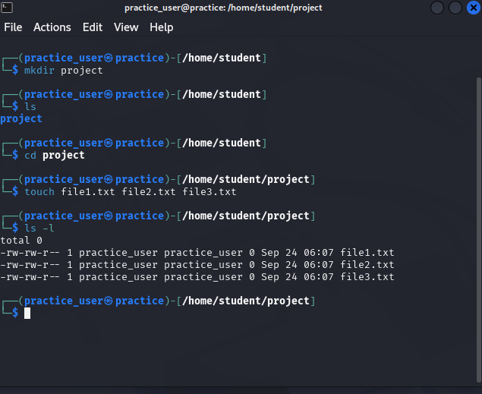

- Explain the difference between absolute path and relative path with proper examples.
- An absolute path specifies the complete path from the root directory to a file or folder, regardless of the current working directory. It always starts with a /
e.g.) /home/student/project/file1.txt
This path will point to the same file no matter where you currently are in the file system.

- A relative path specifies the location of a file or folder relative to the current working directory. It does not start with / and changes meaning depending on where you are in the file system.
e.g.) project/file1.txt

If your current directory is /home/student, this relative path points to the same file as /home/student/project/file1.txt

- What command will give you the already executed command traces in the terminal. Give output snapshot.

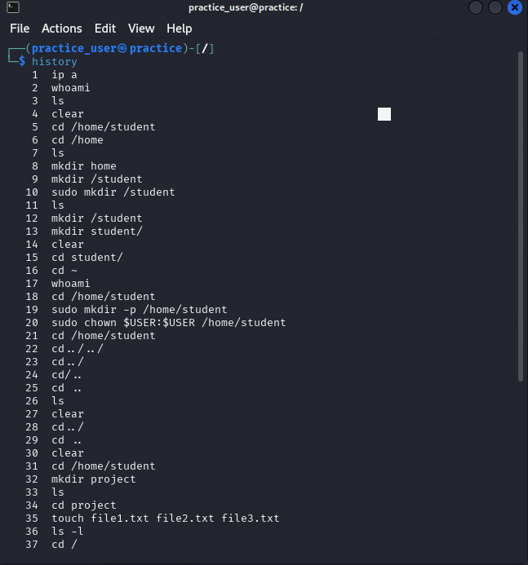
- Compare the working functionality of find and locate command. Which one is faster and why?
- The find command searches for files and directories in real-time by scanning the directory tree starting from a specified location. It allows complex search options such as name, type, size, modification date, and permissions.
e.g.) find /home/student/project -name "file1.txt"
This searches for file1.txt inside /home/student/project and its subdirectories.

- The locate command searches for files using a pre-built database of file names, which is updated periodically (usually via the updatedb command). It is much faster because it does not scan the filesystem in real-time.
e.g.) locate file1.txt

This quickly returns the paths of all files named file1.txt from the database.

Thus, locate is faster than find because it queries a pre-indexed database, whereas find scans the directory structure in real-time, which can take longer, especially in large filesystems.

- Which command is used to modify file permissions in Linux? Give an example.
- chmod
- e.g.) chmod u+rwx file1.txt

- A file has permissions -rw -r- -r- -. What does this mean?
- The first character “-”indicates that this is a regular file and not a directory
- “rw -” tells that the owner can read and write the file.
- “r- -” tells that the group can only read the file.
- “r- -” tells that Others can also only read the file.

- Explain the difference between chown and chgrp with an example.
- chown (change ownership)is used to change the owner of a file or directory.
e.g.) chown user1 file1.txt // This changes the owner of file1.txt to user1

- chgrp is used to change the group of a file or directory.
E.g.) chgrp group1 file1.txt // This changes the group of file1.txt to group1.

- A file needs to be accessible by multiple users but only writable by the owner. How will you set permissions?
- You can set the file permissions so that the owner can read and write, while the group and others can only read the file.

i.e. ) chmod u=rw file.txt # Owner can read and write
chmod g=r file.txt # Group can only read
chmod o=r file.txt # Others can only read

- How do you check the manual page for any Linux commands?
- You can check the manual page of any Linux command using the man command.
e.g.) man chmod
(This will display the manual page for the chmod command, showing its description, options, usage examples, and related commands.)

